2.

a. Number of instances: 768

b. Number of attributes: 8 plus class (9)

c. List of attributes (NOT abbreviation, should be typed in):

1. Number of times pregnant

2. Plasma glucose concentration a 2 hours in an oral glucose tolerance test

3. Diastolic blood pressure (mm Hg)

4. Triceps skin fold thickness (mm)

5. 2-Hour serum insulin (mu U/ml)

6. Body mass index (weight in kg/(height in m)^2)

7. Diabetes pedigree function

8. Age (years)

9. Class variable (0 or 1)

d. Class labels and their relabelled values:

From: 0 To: tested_negative

From: 1 To: tested_positive

e. Number of instances for each class label:

Class Value Number of instances

0 500

1. 268

3.

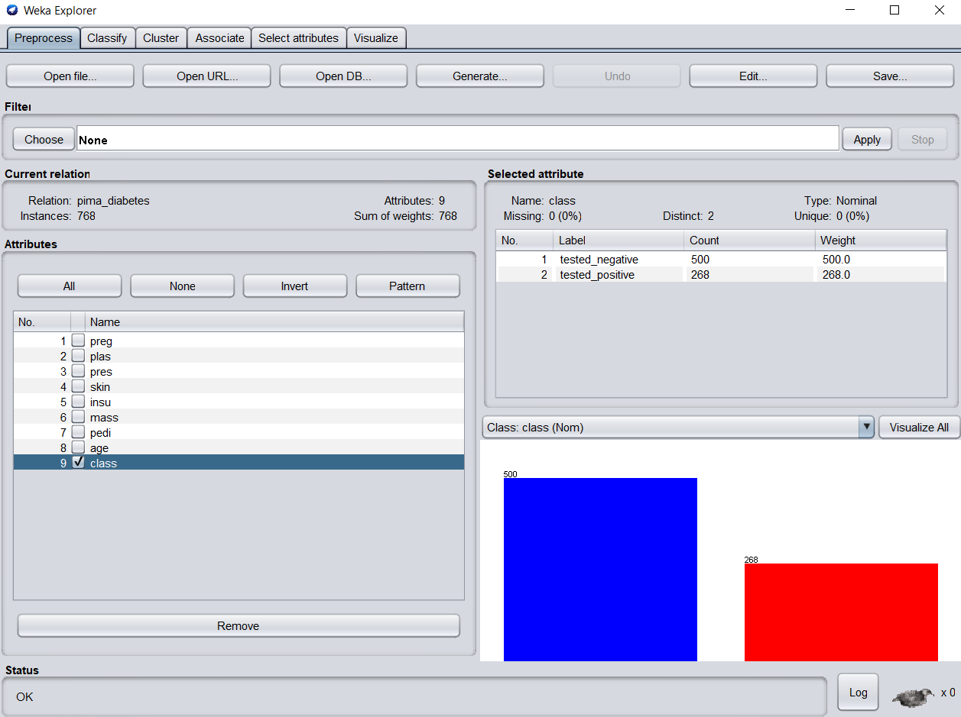

5.

a. Copy and paste the confusion matrix:

=== Confusion Matrix ===

a b <-- classified as

417 83 | a = tested_negative

100 168 | b = tested_positive

b. Number of leaves: 20

c. Size of the tree: 39

d. Correctly classified instances: 585

6.

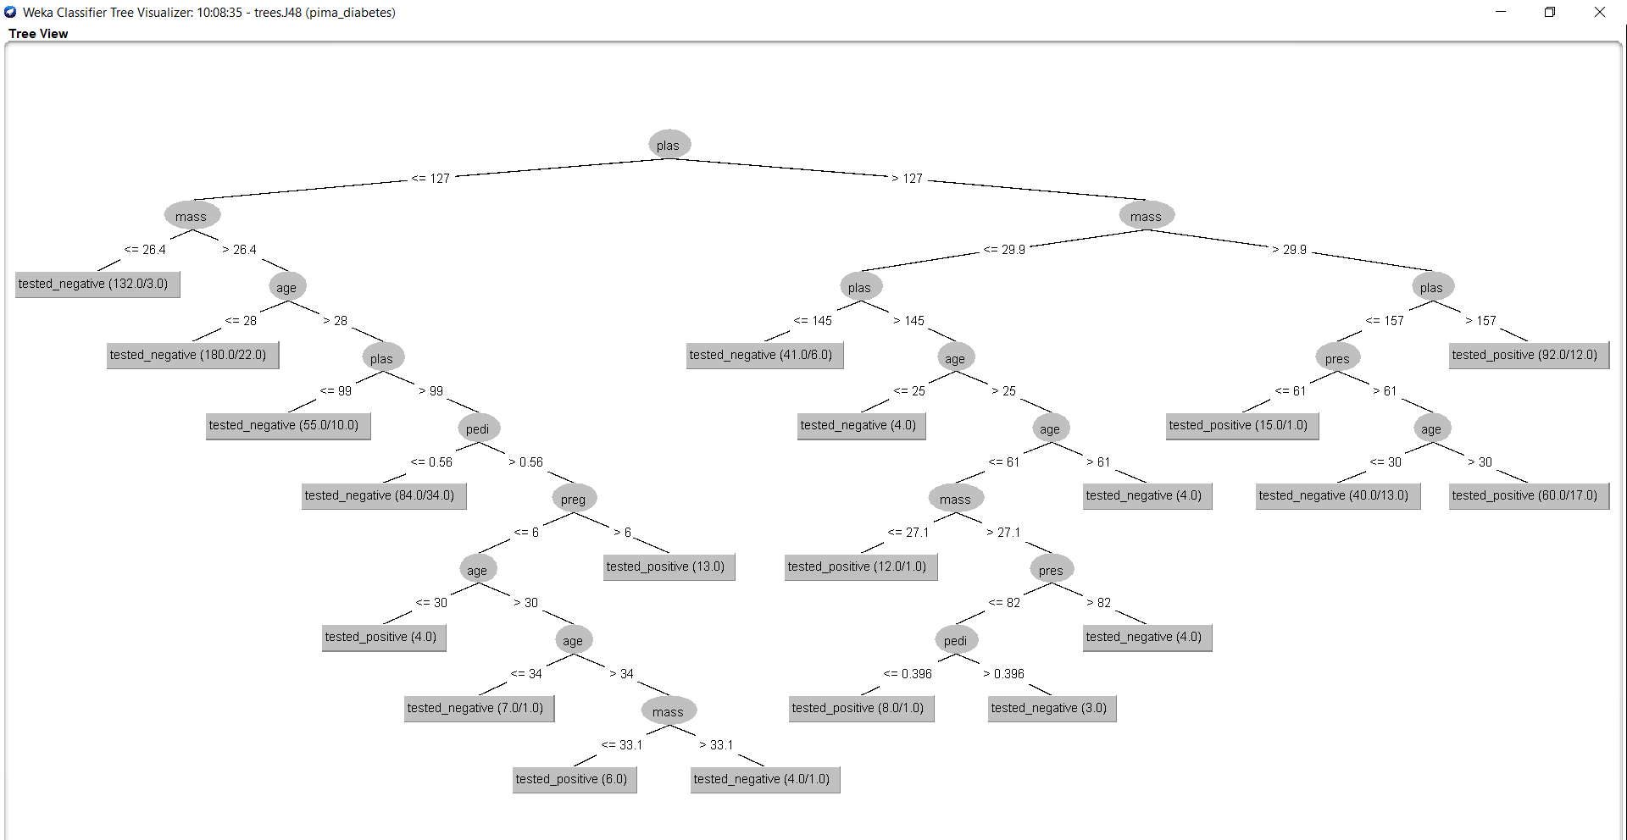

7.

a. Copy and paste the confusion matrix here:

=== Confusion Matrix ===

a b <-- classified as

408 92 | a = tested_negative

107 161 | b = tested_positive

b. Number of leaves: 14

c. Size of the tree: 27

d. Correctly classified instances: 569

8.

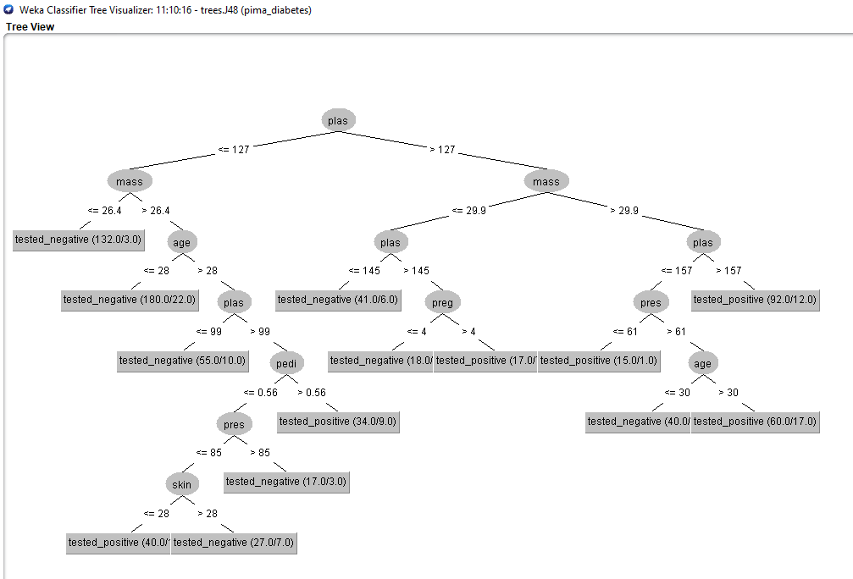

a. Copy and paste the confusion matrix here:

=== Confusion Matrix ===

a b <-- classified as

414 86 | a = tested_negative

98 170 | b = tested_positive

b. Number of leaves: 17

c. Size of the tree: 33

d. Correctly classified instances: 584

10.

a. Copy and paste the confusion matrix here:

=== Confusion Matrix ===

a b <-- classified as

418 82 | a = tested_negative

112 156 | b = tested_positive

b. Number of leaves: 8

c. Size of the tree: 15

d. Correctly classified instances: 574

11.

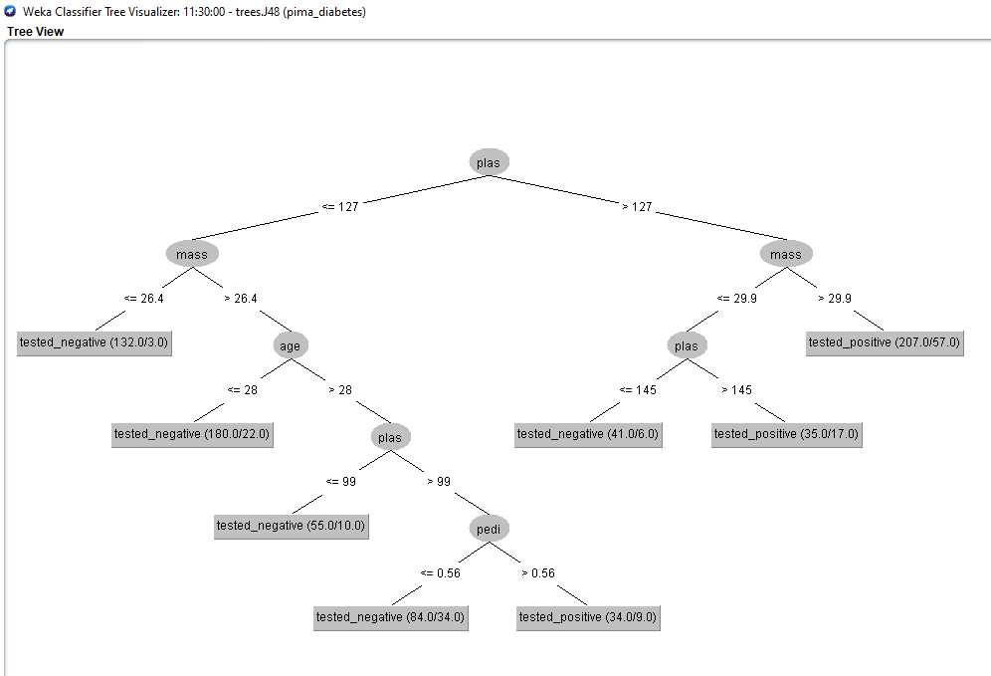

12.

=== Confusion Matrix ===

a b <-- classified as

420 80 | a = tested_negative

111 157 | b = tested_positive

a. Details of random forest: Bagging with 100 iterations

b. Time taken to build model: 0.26 seconds

c. Correctly classified instances: 577